Website Planning Document

# A drawing of a person Description generated with high confidenceSite Name

Brainstorm

# Site Purpose

To tell people the weather

Motto – a Meteor-cre weather service with puns that will make you Flurrious.

# Target Audience

Everyone

# Sitemap

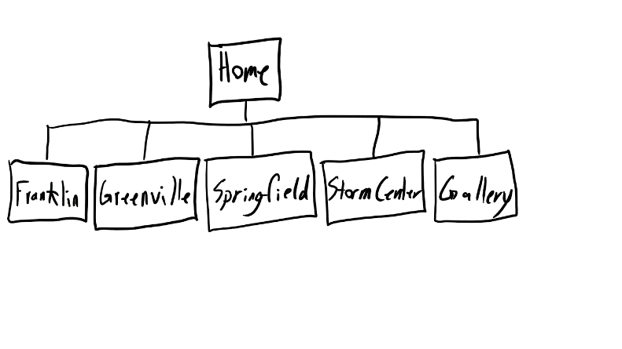



# Color Scheme

A screenshot of a cell phone

Description generated with very high confidence

# Typography

Century Gothic

# Wire Frames

Small Medium Large

A drawing of a person

Description generated with high confidenceA drawing of a person

Description generated with high confidence A close up of text on a whiteboard

Description generated with very high confidence